**Lesson 10 Demo 1**

**Setting up Jenkins’s pipeline job from Git version control system**

**Objective:** Configure a Jenkins Pipeline Jenkins job checked out from Git Repository.

**Tools required:** Jenkins

**Pre-requisites:** You need to have a Jenkins up and running.

Steps to be followed:

1. Log in to Jenkins CI tool and create new Pipeline Jenkins Job.

**Step 1: Log in to Jenkins CI tool and configure freestyle job to trigger build using webhook trigger.**

1. Login to Jenkins CI tool with admin user and click on New Item to create new Jenkins’s job.

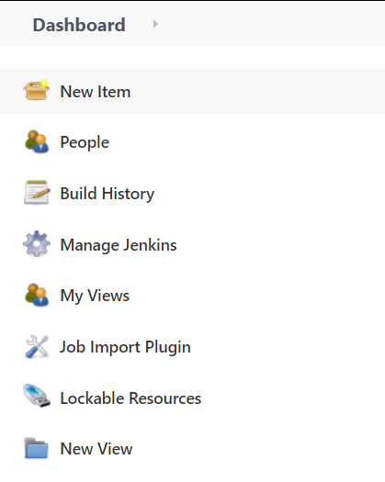

1. Select Pipeline project while creating Jenkins’s job and provide custom job name.

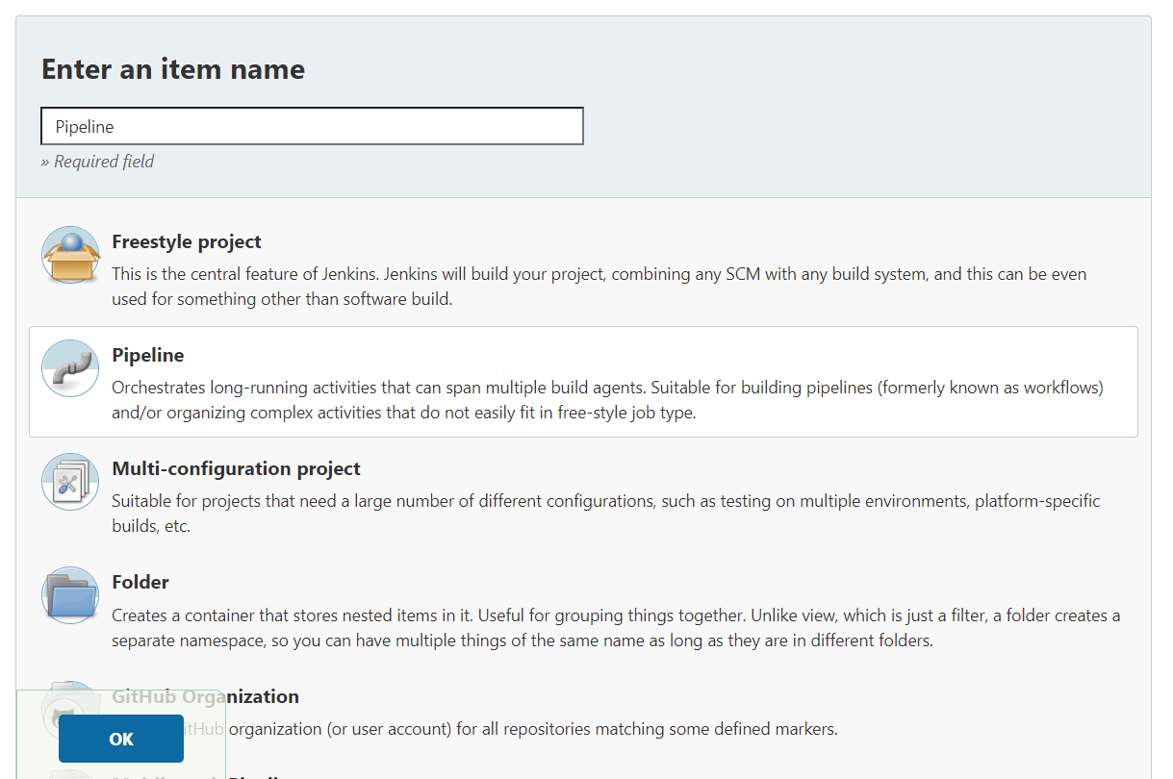

1. Once job name is provided, click on Ok button to save Jenkins’s job and a new configuration screen would be opened.

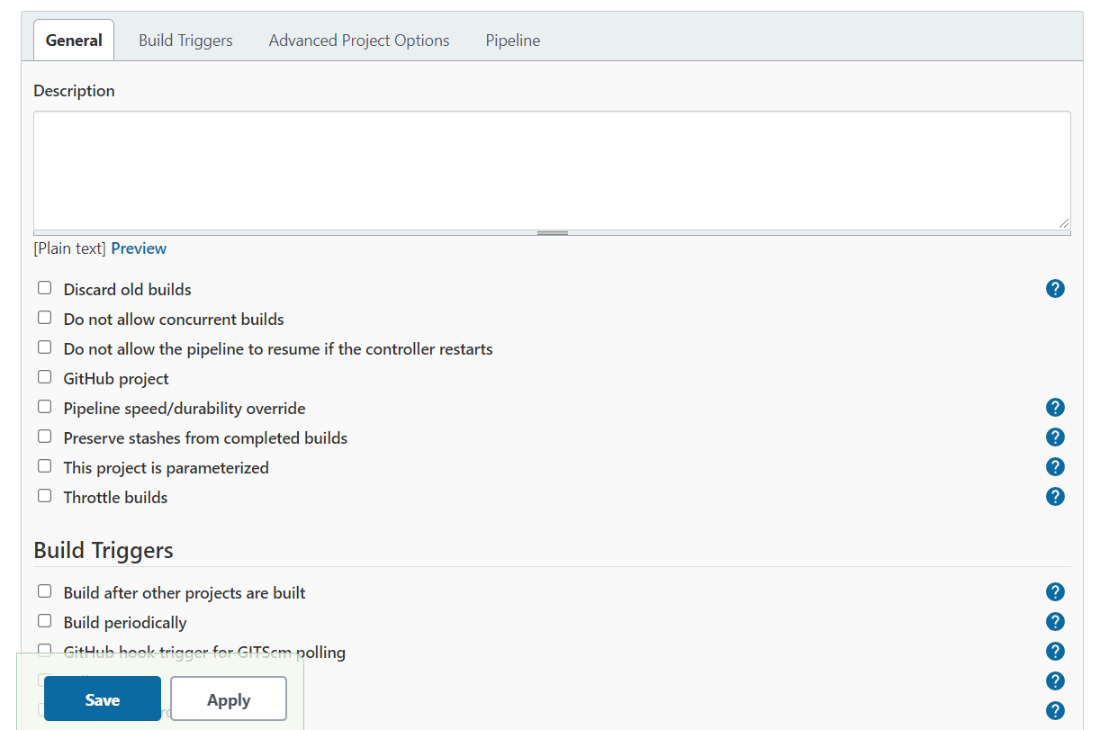

1. In configure screen you need to access Pipeline tab to provide Git repository configurations from where you want to checkout pipeline.

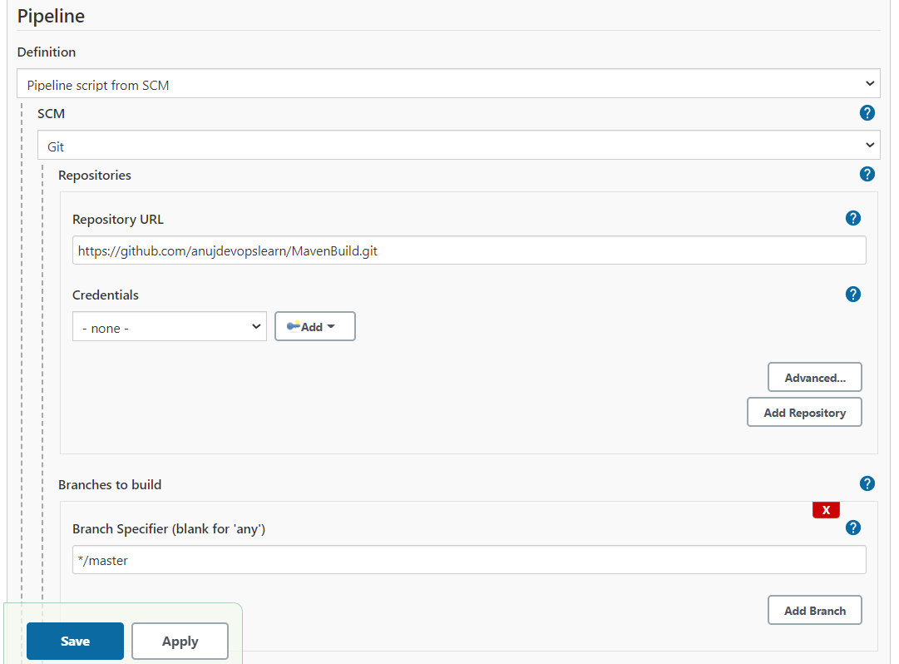

1. In case you are using different Pipeline script you can configure Script path in Pipeline project.

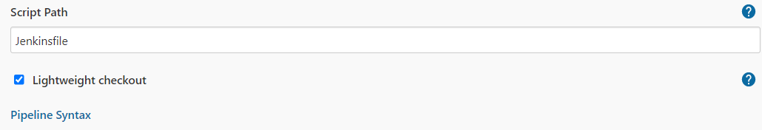

1. Once Git repositories configurations are configured in Jenkins’s job, you can trigger Jenkins’s job build.

